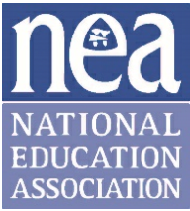



2026 NEA Early Enrollment Pledge
This pledge is a requirement for early enrollment of first-time Active recruits and
returning members, a one-time in their career opportunity to re-join.

As a participant in the: Westminster Education Association (local association)/Colorado Education Association/National Education Association; Early Enrollment Membership Incentive Plan, I am eligible to receive—prior to August 1, 2026, but in no event before April 1, 2026—benefits under the NEA Educators Employment Liability (EEL) Program, as well as access to select NEA Member Benefits Programs.
As a condition of eligibility for these benefits, I agree to pay the appropriate unified Active membership dues for the 2026-2027 membership year in accordance with established payment procedures. Should I fail to do so, my eligibility to receive benefits under the NEA EEL Program shall immediately terminate. In addition, I shall become liable for the cost of any benefits that were provided to me under the NEA EEL Program prior to August 1, 2026.

__________________________________ _____________
Signature Date
__________________________________ _____________
AR, President, or Local Representative Date

